**PROJECT NAME: RWANDA GET YOUR TICKET**

Github link: https://github.com/kappyrw/rwanda_get_your_ticket

* **ONLINE BUS TICKET BOOKING SYSTEM:**

If a customer wants to book the ticket, then he/she must be registered, an unregistered user cannot book the ticket. Registration is the first step of booking the tickets for any one.

There are many factor’s or functional requirement for buying or selling the bus tickets some of them are given below;

* Registration
* Login
* Search bus
* Seat viewing
* Payment
* Logout
* Generate ticket
* Add ticket

Now we can over-view and describe all these functional requirements in detail.

* Registration:

If the customer wants to buy the ticket, then he must be registered. Unregistered customers cannot buy ticket.

* Login:

Customers can log in to the system by entering a valid user id and password .

* Changes to cart:

After login user can change or cancel the booking.

* Payment:

**Hardware requirements to be used**

1. **Computer**
2. **Telephone**
3. **Flash disks**

For customer, there are many types of billing will be prepaid as a debit or credit. Without payment any customer cannot get ticket.

* Logout:

After registration and payment user will be logged out.

* Technical issues:

System work on client-server Architecture. It will require an internet server.

* Interface requirements:

Various interfaces for the product could be …..

* Login page
* Registration page
* There should be new, cancel, and search options are available
* Customer information, movies list, ticket price, seat booking information.

**Purpose:**

The purpose for looking comprehensive solution to manage to online movie ticket booking.

* Online ticket statistics
* Online ticket booking
* Online ticket review

**The solutions this project is going to solve**

For consumers, the online ticket **makes it easy to purchase tickets**, because the consumers do not need to come to the sales agent for purchasing bus tickets. As for the companies, online tickets affect managing transaction data, safer and as a promotional media for the companies.

**SOME SCREENSHOOT OF FRONT PAGE**

**LOGIN FRONT PAGE**

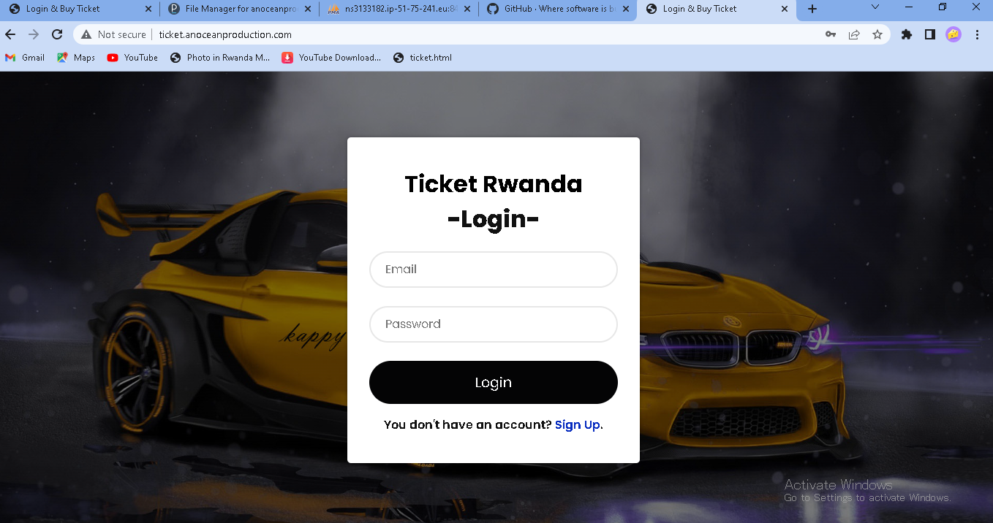

**SIGNUP FRONT PAGE**

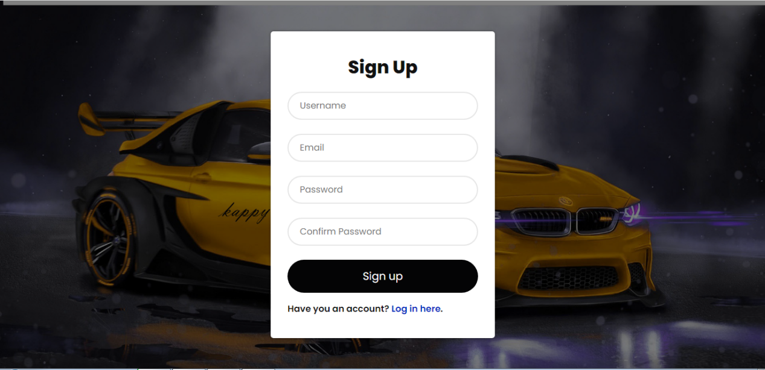

**DATABASE FRONT PAGE**

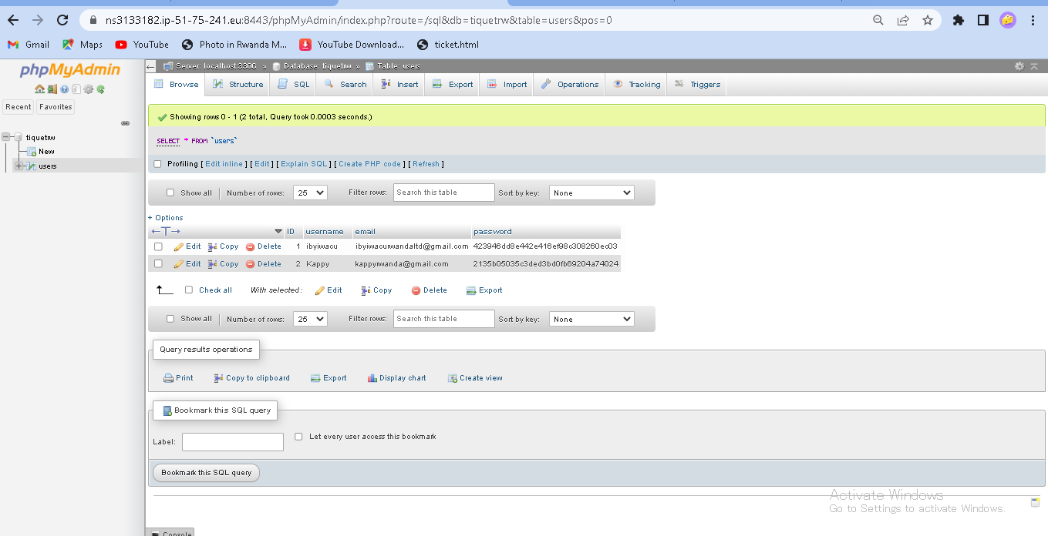

**When you enter wrong password or an email in login**

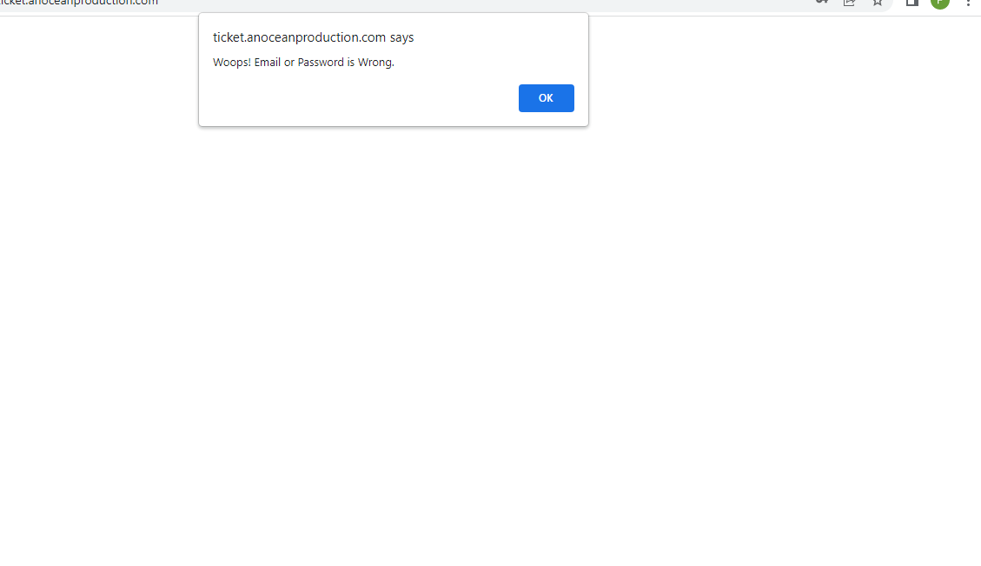

**During signup and you confirm unmatch password**

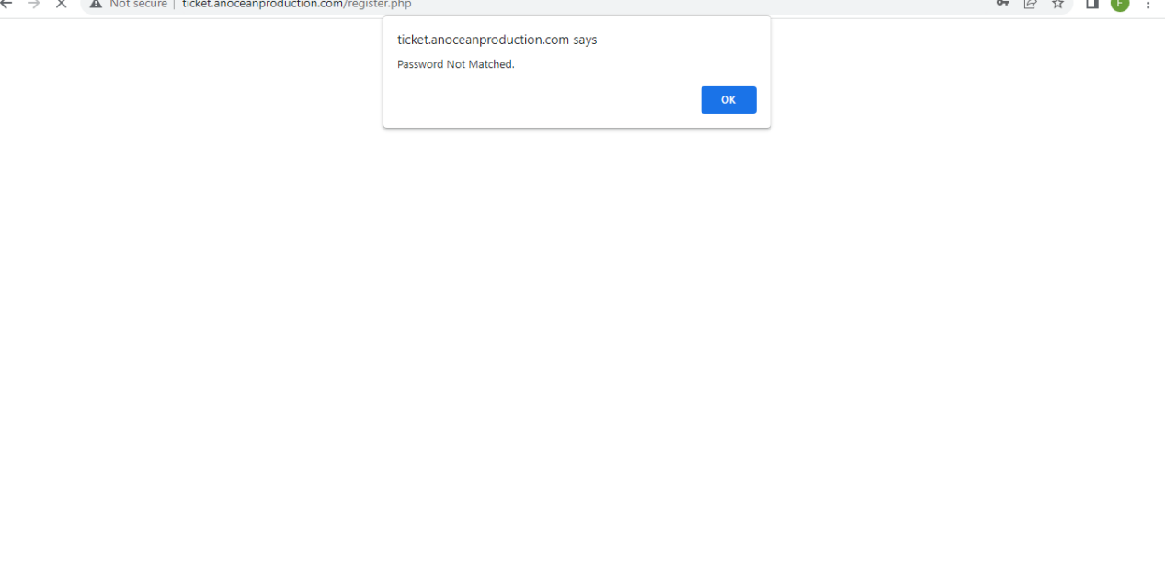

**ERD**

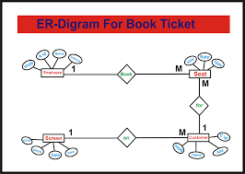

**Conclusion online ticket booking system is very big to maintain but**

**It provides excellent facilities to accomplish the goal and**

**Help to reduce a complex paper work.**